**University of Central Punjab**

Assignment # 4

**Time & Date Deadline**: 22nd June, 2022 11:59 PM

**Course**: Programming Fundamentals (PF)

# Submission Instructions:

1. You have to submit 1 zip file containing:
   * MS word document containing C++ programs with screen shot of console
   * .cpp file of the program and input files where required
2. You have to upload your assignments on CMS.
3. Plagiarism is not acceptable. If someone’s assignment is plagiarized, that student will be given F straight away, so beware.
4. The deadline for this assignment is **June 22nd, 2022, 11:59 pm**. No late submission will be accepted.

**Learning Objectives:** Demonstrate knowledge of 2D arrays and dynamic memory allocation/deallocation in programming(C++).

**Task:**

Write a C++ program that reads names from 2 different files “First_Name.txt” and “Last_Name.txt” in dynamic 2D arrays. Now merge first names with last names in a single dynamic 2D Array, and write full names in a new file i.e., “Full_Name.txt in alphabetically arranged manner as shown below.

5

Iqra

Sana

Kashif

Aslam

Shahid

5

Khan

Sajid

Ahmed

Ali

Sheikh

5

Aslam Ali

Iqra Khan

Kashif Ahmed

Sana Sajid

Shahid Sheikh

**First_Name.txt** **Last_Name.txt Full_Name.txt**

Each file contains a number at the start representing number of names in the file. Make separate function for each task to maintain the modularity in the code.

**Note:** Do not forget to free the memory (using a separate function) if you are using heap memory.

**Screenshot of console:**

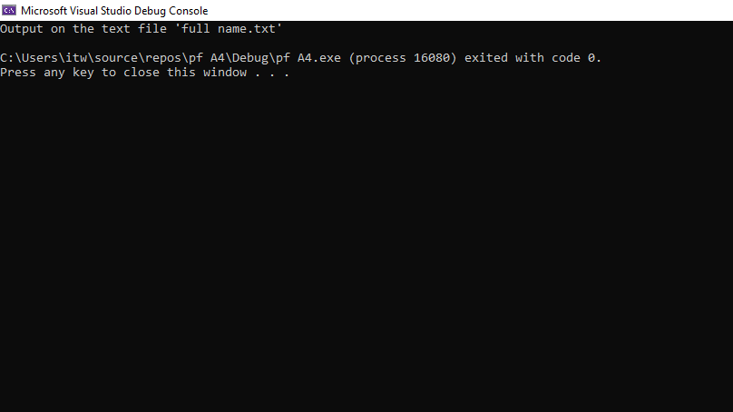

🡨--------------------------------------------------------------------------------------------------🡪

***“When you are not practicing, remember somewhere someone is practicing, and when you meet him, he will win.”***